

Monochromator
MSH-300

Factory report for serial number 19523

LOT-QuantumDesign GmbH
Im Tiefen See 58
64293 Darmstadt
Tel.: +49 6151 8806-0
Fax. +49 6151 8806-89
E-mail: info@lot-qd.de
www.lot-qd.com

- Hardware specification

This monochromator is connected via USB and a mains C13 IEC three pin socket with the following settings:

VID: 1240 PID: 5893

This monochromator has a single entrance slit, a single exit slit and an optional filter wheel in the following configuration (dimensions in mm). The entrance and exit slits have the following mounting hole pattern, with the centre of the slit in the centre of the hole pattern:
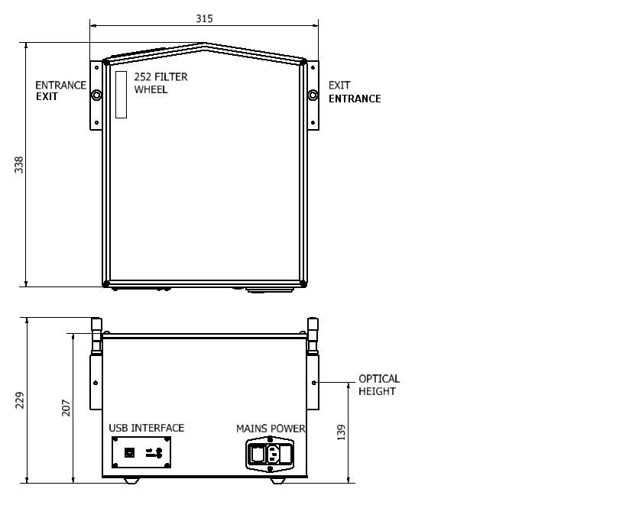

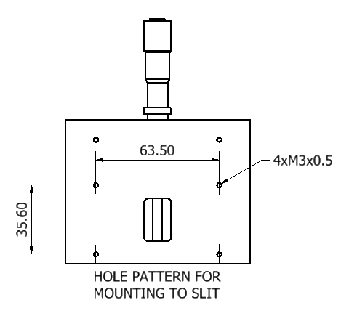

- Monochromator configuration

Gratings present

Turret  position | Grating code | Ruling density (grooves per mm) | Blaze wavelength (nm)
1 | MSG-T-1200-500 | 1200 | 500
2 | MSG-T-600-1250 | 600 | 1250
3 | MSG-T-300-300 | 300 | 3000

Filters present

Position | Filter | Wavelength used (nm)
1 | 320FG01-25 | 360
2 | 530FG05-25 | 570
3 | 950FH90-25 | 980
4 | 1.65ILP-25 | 1800
5 | 2.40ILP-25 | 2600
6 | SHUTTER | -

- MSH-300 wavelength calibration

The monochromator was set up with detector and detection electronics to permit performing spectral measurements.

A high pressure mercury lamp was mounted to the monochromator entrance port. For each grating in turn, a coarse calibration comprises the visual alignment of the zero order contribution of each grating on the exit slit. Subsequent spectral measurements determined the wavelength at which mercury lines were measured, and compared with the wavelengths at which these lines were expected. Based on full width half maximum analysis of each line, and for each state of any swing away mirrors in the system, a best fit was found to relate wavelength selected to steps of the stepping motor drive from a park position through two parameters zord, the offset, and alpha, a linear scaling factor.

Calibration factors

Turret position | Grating | Zord | Alpha
1 | MSG-T-1200-500 | 5246 | 1.0020
2 | MSG-T-600-1250 | 171974 | 1.0007
3 | MSG-T-300-300 | 338768 | 1.0000

Deviations

MSG-T-1200-500
Hg line (nm) | Deviation (nm)
365.02 | 0
404.66 | -0.2
435.84 | +0.1
546.07 | +0.2
576.96 | -0.1
730.04 | +0.2
809.32 | +0.1
871.68 | 0

MSG-T-600-1250 Second Order
Hg line (nm) | Deviation (nm)
365.02 | -0.2
404.66 | 0
435.84 | -0.1
546.07 | -0.1
576.96 | 0
730.04 | -0.2
809.32 | -0.2
871.68 | 0

MSG-T-300-3000 First order
Hg line (nm) | Deviation (nm)
871.68 | -0.20
1092.14 | +1.00
1638.21 | -0.20
2184.28 | -0.60
2730.35 | -0.60
3276.42 | -0.60
3822.49 | -1.00
4368.56 | +0.20

- Traceability
The emission wavelength of mercury lines are not subject to calibration and cannot change. Lists of known mercury emission wavelengths can be obtained from sources such as NIST (http://www.nist.gov/pml/data/handbook).

